**K-Means**

K-Means is an unsupervised learning algorithm. There is no labelled data for this clustering. What this K-means clustering algorithm does is it used to find groups that have not been labelled explicitly in the data. This can be used to identify unknown groups in data sets that are complex. The situations that the K-Means algorithm will be most useful will be document clustering, market segmentation, image segmentation and image compression.

An example of where this algorithm has been used has been used has been to show the creation of 3 clusters which are in different colours as you can see here below:

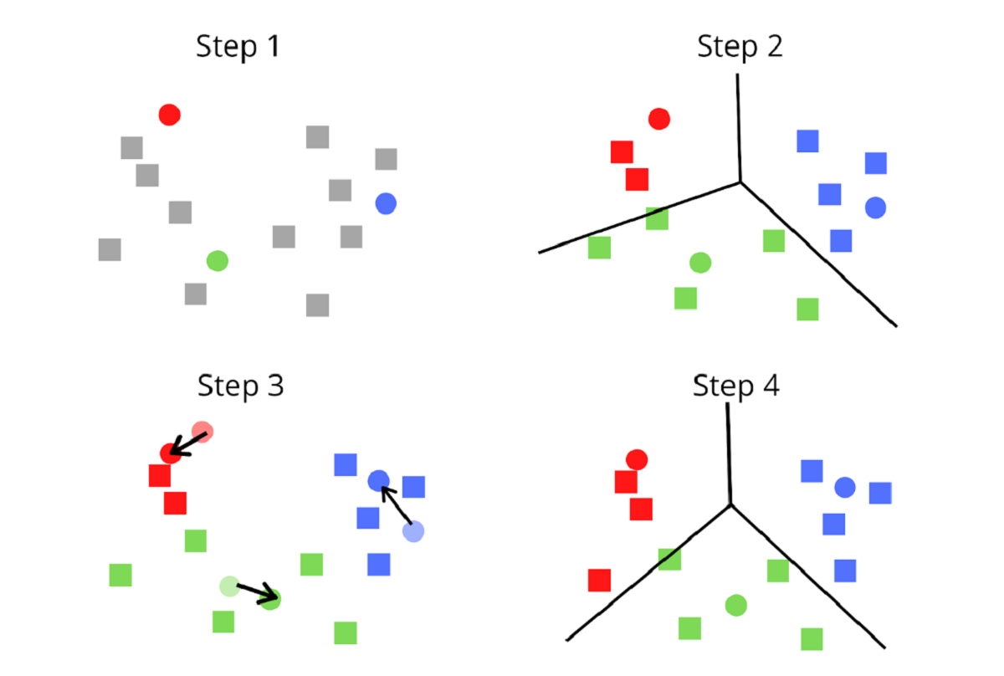

This can be used to analyse patterns and draw conclusions. This involves the analysis of each cluster formed the computer is not able to understand what is unique about each cluster. This is where human expertise comes in. for examples in this case the crimes committed in red may not have been committed using a similar gun or that all the crimes shown in blue may be due to theft of jewellery where people walking in the road and the assailants were travelling on a motor bike etc. This helps to find crime patterns and trend correlations. The law enforcement officers can deploy additional and suitable resources for detection and suppression of criminal activities once a specific pattern has been detected.